Project Design Phase-II

Data Flow Diagram & User Stories

|  |  |
| --- | --- |
| Date | 17 March 2025 |
| Team ID | SWTID1744456946 |
| Project Name | MediBoard |
| Maximum Marks | 4 Marks |

**Data Flow Diagrams:**

A Data Flow Diagram (DFD) is a traditional visual representation of the information flows within a system. A neat and clear DFD can depict the right amount of the system requirement graphically. It shows how data enters and leaves the system, what changes the information, and where data is stored.

Level 0

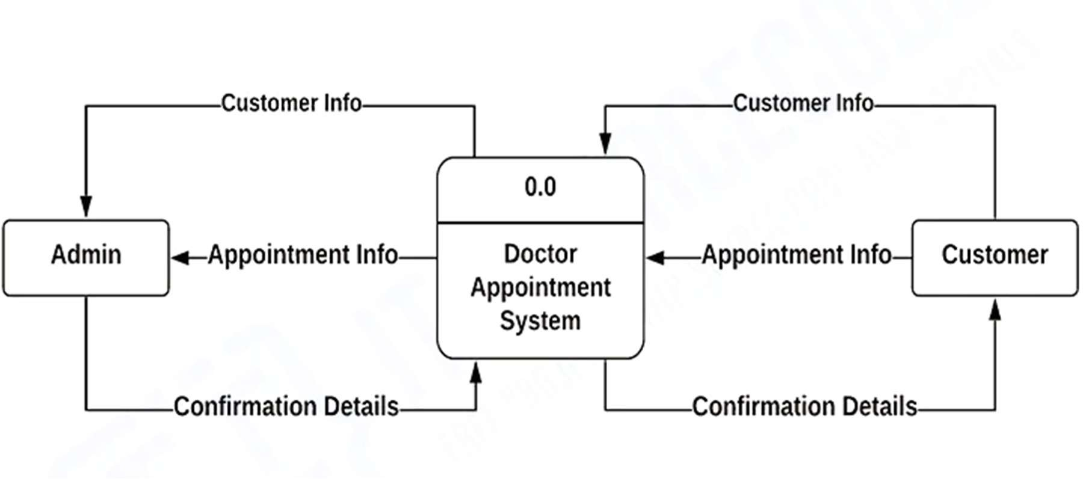

Level 1

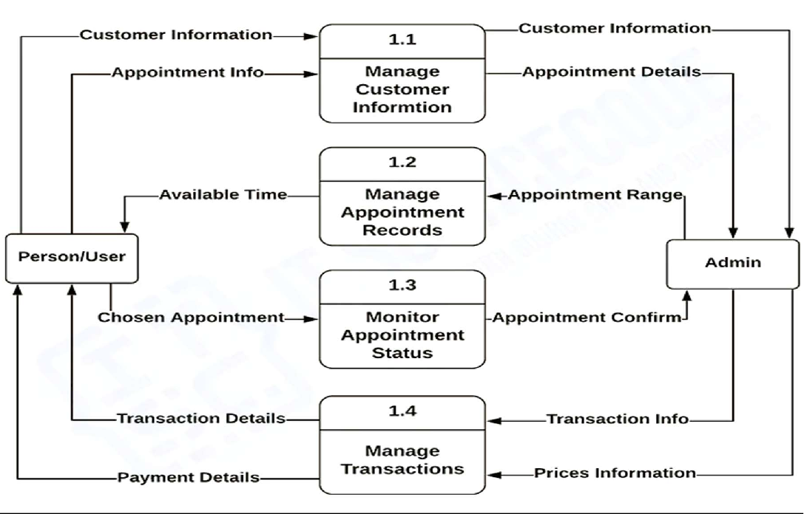

**User Stories**

|  |  |  |  |  |  |  |
| --- | --- | --- | --- | --- | --- | --- |
| **User Type** | **Functional**  **Requirement (Epic)** | **User Story Number** | **User Story / Task** | **Acceptance criteria** | **Priority** | **Release** |
| Customer (Mobile user) | Registration | USN-1 | As a user, I can register for the application by entering my email, password, and confirming my password. | I can access my account / dashboard | High | Sprint-1 |
| Customer (Mobile/Web) | Registration | USN-2 | As a user, I will receive confirmation email once I have registered for the application | I can receive confirmation email & click confirm | High | Sprint-1 |
| Customer (Mobile/Web) | Registration via Facebook | USN-3 | As a user, I can register for the application through Facebook | I can register & access the dashboard with Facebook Login | Low | Sprint-2 |
| Customer (Mobile/Web) | Registration via Gmail | USN-4 | As a user, I can register for the application through Gmail | I can register and access the dashboard using  Gmail. | Medium | Sprint-1 |
| Customer (Mobile/Web) | Login | USN-5 | As a user, I can log into the application by entering email & password | I can access my account/dashboard after login. | High | Sprint-1 |
| Customer (Web/Mobile) | Dashboard | USN-6 | As a user, I can view my upcoming and past appointments on the dashboard | I can see a list of all appointments with date,  time, doctor info, and status. | High | Sprint-II |
| Customer (Web user) | Dashboard | USN-7 | As a user, I can cancel an appointment from the dashboard | I can cancel any upcoming appointment and see updated status. | High | Sprint-II |
| Doctor | Dashboard | USN-8 | As a doctor, I can view all appointments scheduled with me on the dashboard. | I can see patient details  and appointment status for each scheduled slot. | High | Sprint-II |
| Doctor | Dashboard | USN-9 | As a doctor, I can update the status of each appointment (e.g., completed, cancelled). | I can mark appointments with updated statuses. | Medium | Sprint-II |
| Customer / Doctor | Profile Management | USN-10 | As a user, I can edit my profile details like name, age, specialization, or contact info. | I can view and successfully update my  profile details. | Medium | Sprint-II |
| Customer (Web/Mobile) | Appointment Booking | USN-11 | As a patient, I can search for doctors and book appointments by selecting date and time. | I receive a confirmation and appointment is visible on my dashboard. | High | Sprint-I |